GUEST’S NAME DESIGNER’S NAME

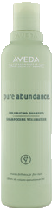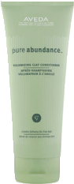LAST VISIT NEXT VISIT AROMA PREFERENCE

HAIR CARE PURESCRIPTION™

THINNING | SOLUTIONS | CREATE | VOLUME | INVIGORATING | CARE

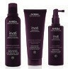
invati advanced™ exfoliating shampoo

invati advanced™ thickening conditioner

invati advanced™ scalp revitalizer

invati men™ nourishing exfoliating shampoo

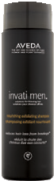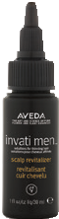invati men™ scalp revitalizer

pure abundance™ volumizing shampoo

pure abundance™ volumizing clay conditioner

rosemary mint™ shampoo

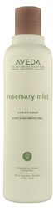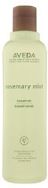rosemary mint™ conditioner

ADD | MOISTURE | PROTECT | COLOR | SOOTHING | CARE

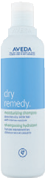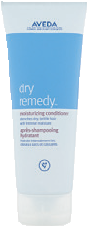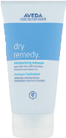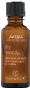dry remedy™ moisturizing shampoo

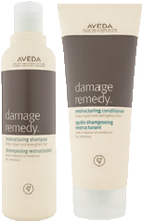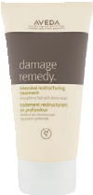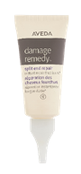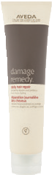dry remedy™ moisturizing conditioner

dry remedy™ moisturizing masque

dry remedy™ daily moisturizing oil

color conserve™ shampoo

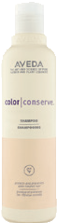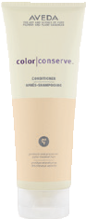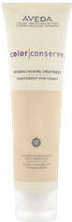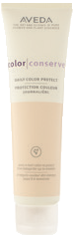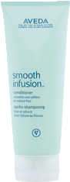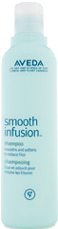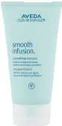color conserve™ conditioner

color conserve™ strengthening treatment

color conserve™ daily color protect

shampure™ shampoo

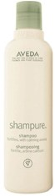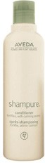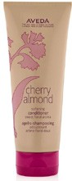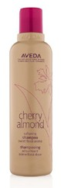shampure™ conditioner

REPAIR DAMAGE |  |  | SMOOTH |  | & | STRAIGHTEN |  | SOFTENING CARE
damage remedy™ restructuring shampoo  damage remedy™ restructuring conditioner  damage remedy™ intensive restructuring treatment |  | damage remedy™ split end repair  damage remedy™ daily hair repair |  | smooth infusion™ shampoo  smooth infusion™ conditioner  smooth infusion™ smoothing masque |  |  |  | cherry almond
 |  |  |  |  |  |  |  | softening shampoo
 |  |  |  |  |  |  |  | cherry almond
 |  |  |  |  |  |  |  | softening conditioner
AVEDA MEN | SECOND-DAY HAIR |  |  | DEFINE CURL |  |  |  | SUN CARE
aveda men  pure-formance™ shampoo |  |  | shampure™ dry shampoo |  |  |  | be curly™ co-wash | sun care protective hair veil
aveda men  pure-formance™ conditioner |  |  | rinseless refresh |  |  |  | be curly™ shampoo | sun care  hair & body cleanser
aveda men  pure-formance™ exfoliating shampoo |  |  | heat relief™ |  |  |  | be curly™ conditioner | sun care  after-sun hair masque

SCALP CARE
LIP CARE

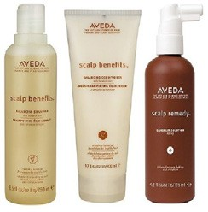
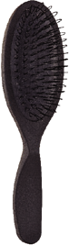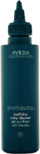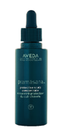scalp benefits™ balancing shampoo

scalp benefits™ balancing conditioner

scalp benefits™ dandruff solution

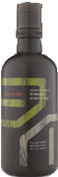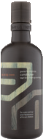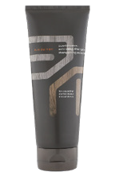pramasana™
purifying scalp cleanser

pramasana™
protective scalp concentrate

pramasana™ exfoliating scalp brush

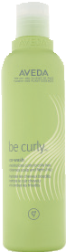
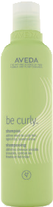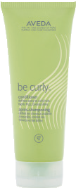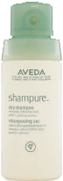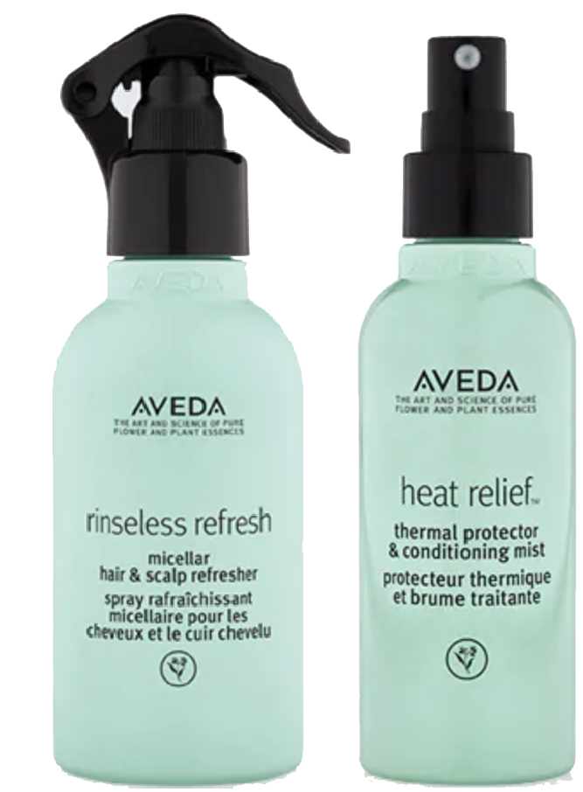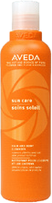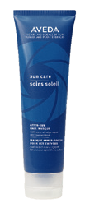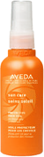feed my lips™
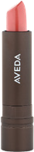
nourish-mint™ lipstick

feed my lips™ pure nourish-mint™ lip liner

feed my lips™ pure nourish-mint™ lip primer

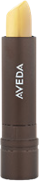
feed my lips™ pure nourish-mint™ lip treatment

HAIR STYLING | PREP STYLE FINISH

™

l
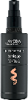

GUEST INSTRUCTIONS

e

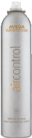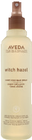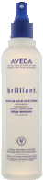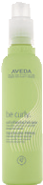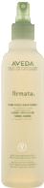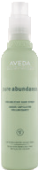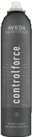ADDITIONAL RECOMMENDATIONS

1
PREP
for use on damp hair
2
STYLE
for use on damp hair
3
FINISH
for use on dry hair
PROTECT FROM HEAT  speed of light™ brilliant™ damage remedy™ smooth infusion™ blow dry accelerator spray damage control daily hair repair naturally straight  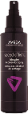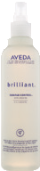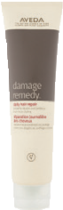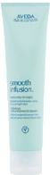  PREPARE FOR STYLING  pure-abundance™ smooth-infusion™  style prep™ style prep smoother™  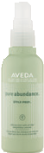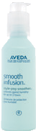 |  |  |  |  | thickening heat  tonic™ relief™  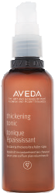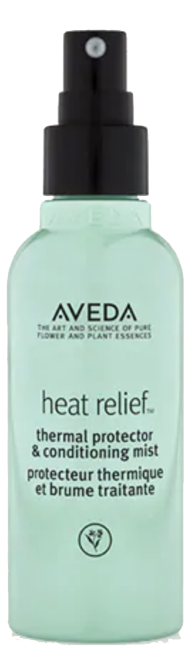  be curly™ style prep™  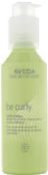
SMOOTH / STRAIGHTEN |  | VOLUME | DEFINE CURL | CREATE HOLD
smooth infusion™ brilliant™ smooth infusion™ nourishing universal glossing  styling creme styling creme straightener  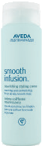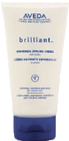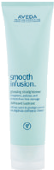  smooth smooth occasionally straighten | volumizing phomollient™ texture be curly™ aveda men™  tonic™ styling tonic curl enhancer pure-formance  foam liquid pomade  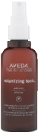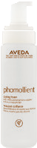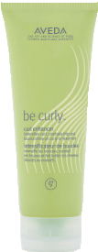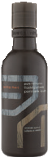  enhance light hold |  |  |  | confixor™ brilliant™ flax seed aloe aveda men liquid retexturizing strong hold pure-formanc  gel gel sculpting gel firm hold ge  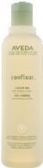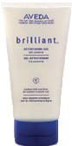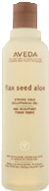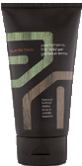  firm hold
CREATE TEXTURE
light elements™ pure abundance™ texturizing creme hair potion  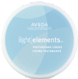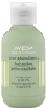  light hold | light elements™ aveda men aveda men control paste™ defining whip pure-formance™ pure-formance™ finishing paste  grooming cream pomade |  |  |  | aveda men light elements™  pure-formance™ shaping wax grooming clay  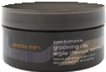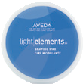  firm hold
ADD SHINE
light elements™ brilliant™ brilliant™ brilliant™ brilliant™ sun care protective smoothing fluid shine on spray emollient finishing gloss humectant pomade anti-humectant pomade hair veil
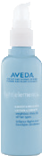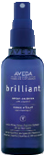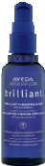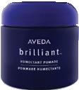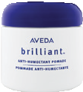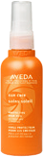
HOLD WITH HAIR SPRAY
air control™ witch hazel light hold hair spray light hold hair spray  light hold | brilliant™ be curly™ firmata™ medium hold hair spray curl enhancing hair spray firm hold hair spray |  |  |  | pure abundance™ control force™ volumizing hair spray firm hold hair spray  firm hold

